KK87 -

Functionality
During Product Cost Collectors settlement, either WIP (at target cost) or Variance (if or both) is posted.
Through the production process, Product Cost Collectors are debited with actual costs. The actual costs posted to a product cost collector can be more or less than the value with which a product cost collector was credited when the goods receipt was posted. When you settle, this difference between the debit and credit of the product cost collector is transferred to Financial Accounting (FI). Settlement also feeds data from Cost Object Controlling to other components.
The following can happen during the settlement process:
The order balance can be reduced to zero by transferring to Financial Accounting (FI) the difference between the preliminary inventory valuation (goods receipt) and the actual costs incurred. The price difference can also be transferred to Profit Center Accounting (EC-PCA).
The total variance can be transferred to profitability segments in Profitability Analysis (CO-PA). This enables you to see an additional contribution margin in CO-PA. You can transfer the individual variance categories of the total variance to value fields in CO-PA in combination with certain cost elements or cost element groups.

Scenario
You want to post WIP or Variance after WIP and Variance calculation.

Requirements
WIP and Variance was calculated.

Menu Path | Accounting → Controlling → Product Cost Controlling → Cost Object Controlling → Product Cost by Period → Period-End Closing → Single Functions: Product Cost Collector → Settlement → KK87 - Individual Processing
Transaction Code | KK87

1. Double click on KK87 - Individual Processing.

Actual Settlement: Product cost collector

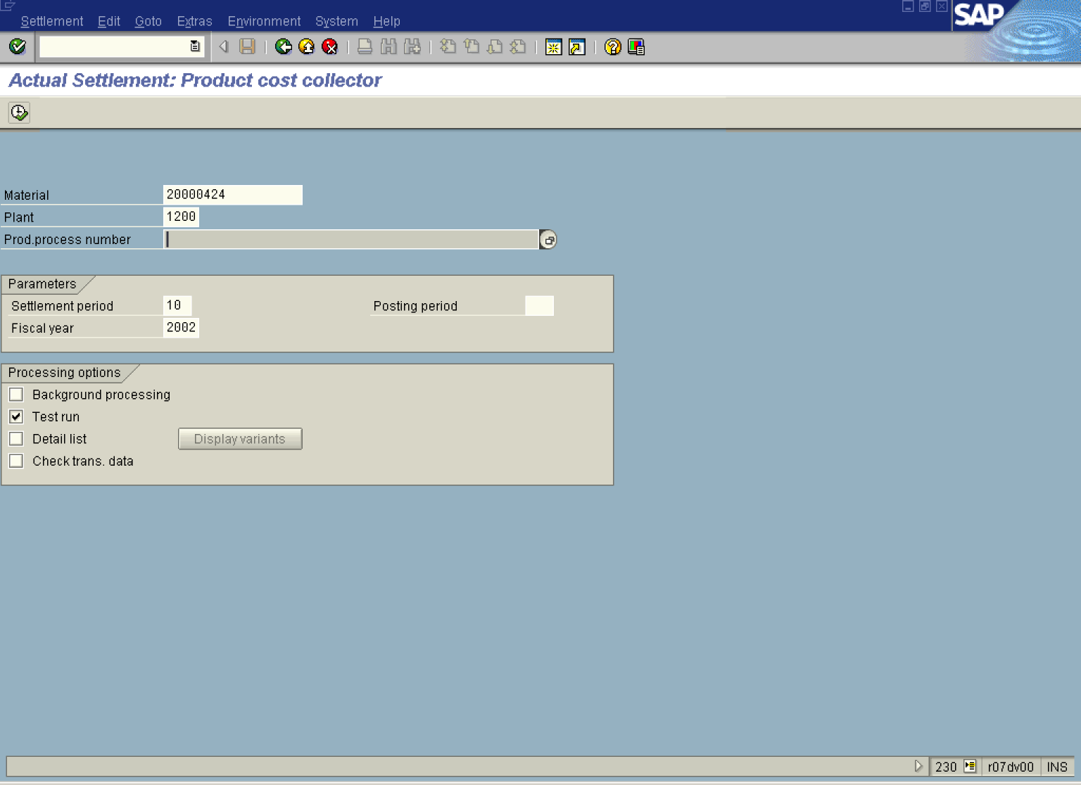

Note: In case that settlement period differs from posting period you should specify the relevant posting period in the field Posting Period.
2. Update the following fields:

Field Name | Field Description | Values
Material | Code identifying a product or component. | Example: 20000424
Plant | Code identifying the operational unit of the company where the material is manufactured and stored | Example: 1200
Settlement period | Number identifying a fiscal month relevant for posting. | Example: 10
Fiscal year | The Fiscal year of settlement | Example: 2002

3. Press [F4] or click the Search button in the Prod.process number field.

Choose production processes for material/plant

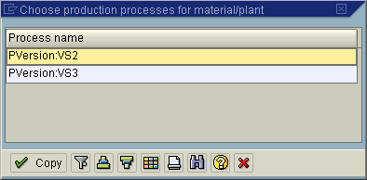

4. Double click on the PVersion:VS2 in list box.
Actual Settlement: Product cost collector

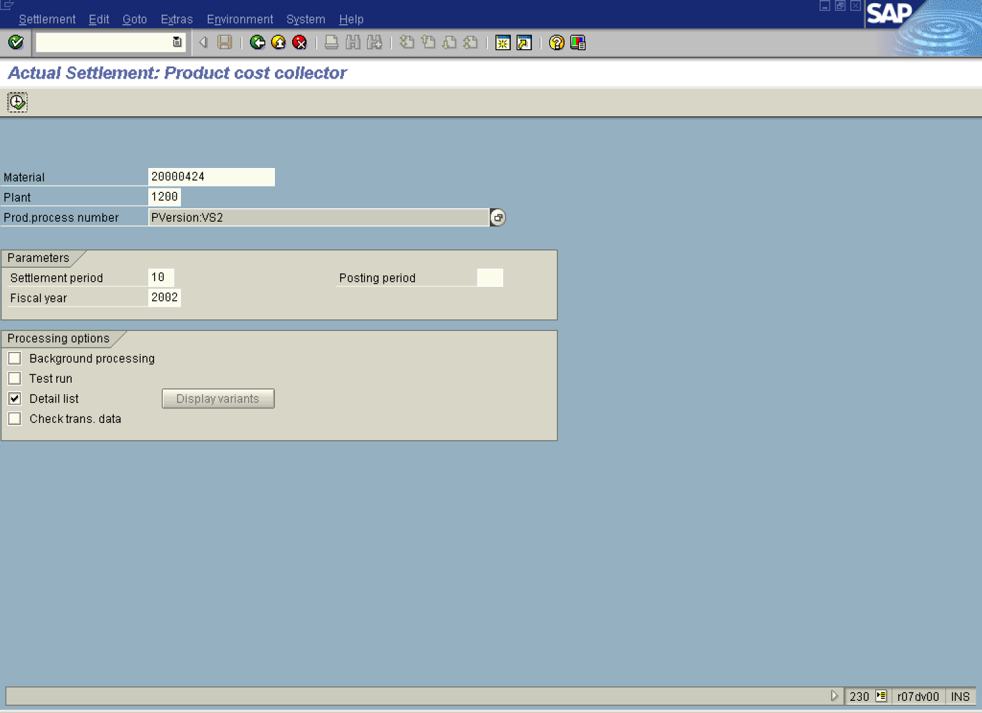

5. Click the Test run checkbox to deselect.
6. Click the Detail list checkbox to select.
7. Click the Execute button.
8. Click the Detail lists button.

Actual Settlement: Product cost collector Detail list

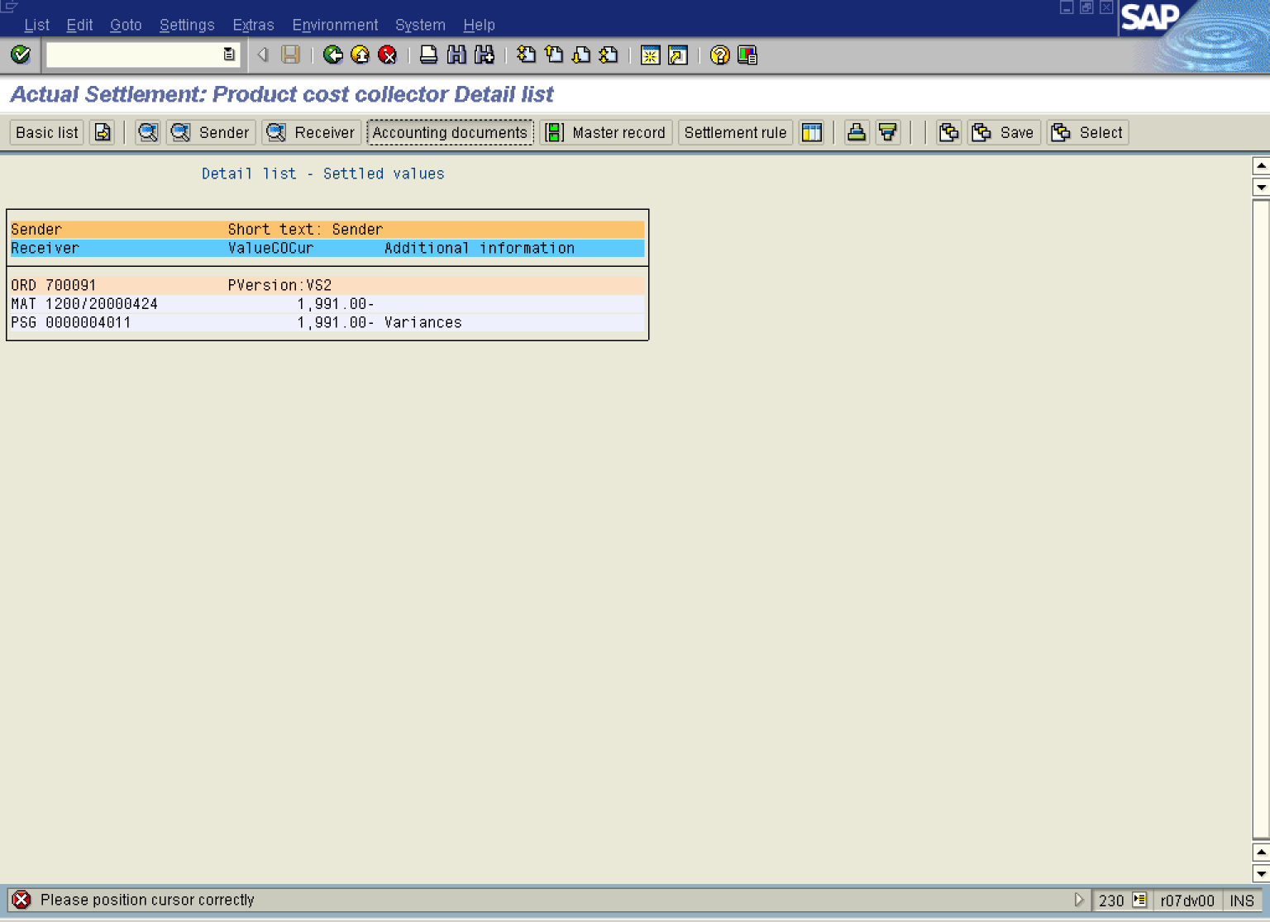

9. Select the relevant line and click the Accounting documents button.

List of Documents in Accounting

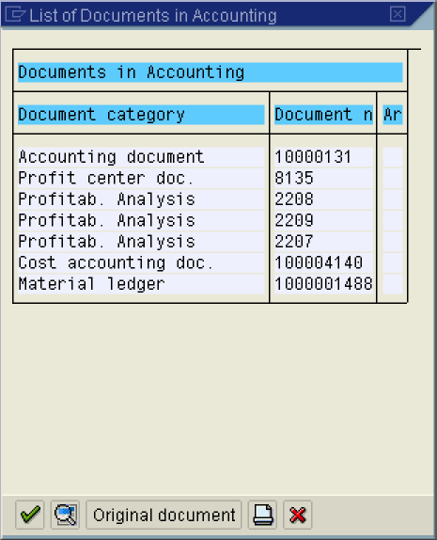

10. Click the Continue button.

Display Document: Overview

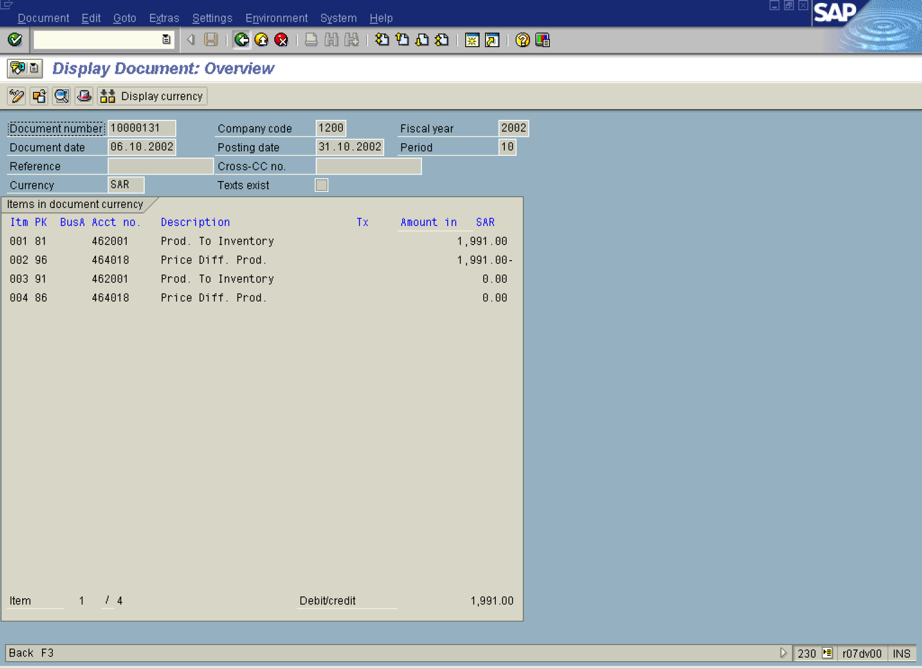

11. Click the Back button.

List of Documents in Accounting

12. Click the Cancel button.

Actual Settlement: Product cost collector Detail list

